Job Description
Job Date: | Job Location: |  | JRA No.:
Job Description:
Permit No. / Other Reference:
Job Step | Hazard / Consequence  Use Hazard Sources on page 2 to identify potential hazards | Controls  Use the Control Hierarchy on page 2 to determine specific, actionable controls which protect against  the hazard |  | Person Responsible  Person who will ensure control is in place

Potential Hazard Sources
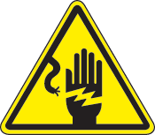
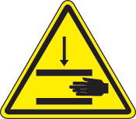
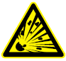
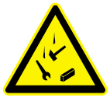
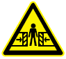
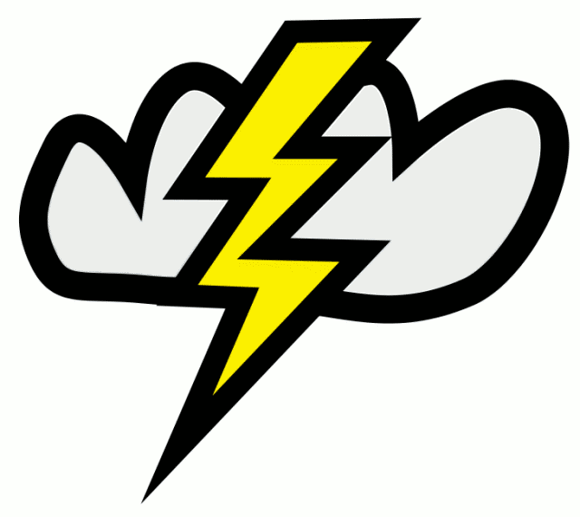
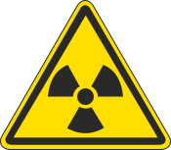
Electrical  - Shock  - Ignition Source  - Grounding | Motion  - Struck By  - Caught Between  - Rotating Equipment | Pressure / Temperature  - Gas/Liquid  - Vacuum  - Hot/Cold Material | Gravity / Energy  - Dropped Objects  - Fall from Elevation  - Tension  - Ground Disturbance | People  - Fatigue  - Ergonomics  - Communication  - SIMOPS  - Community | Environment  - Weather  - Lighting  - Noise  - Confined Space  - Vibration | Hazardous Material  - Flammable  - Asphyxiates  - Radiation  - Biological  - Waste

Work Crew: Sign if all of your questions have been answered and you are ready to proceed.
Name | Signature | Name | Signature

Is Work Safe to Proceed?
By signing below, I confirm that:  - The work location is adequately identified (e.g. hazard tape, barriers)  - The Controls adequately protect against the Hazards identified |  | - The job has been reviewed with the Work Crew  - Each member of the Work Crew is clear on their responsibilities
Job Supervisor | Signature |  | Date
Upon completion of the job advise site supervision of any identified improvement opportunities for future job planning.

